Weapons Free!

Classification Unknown

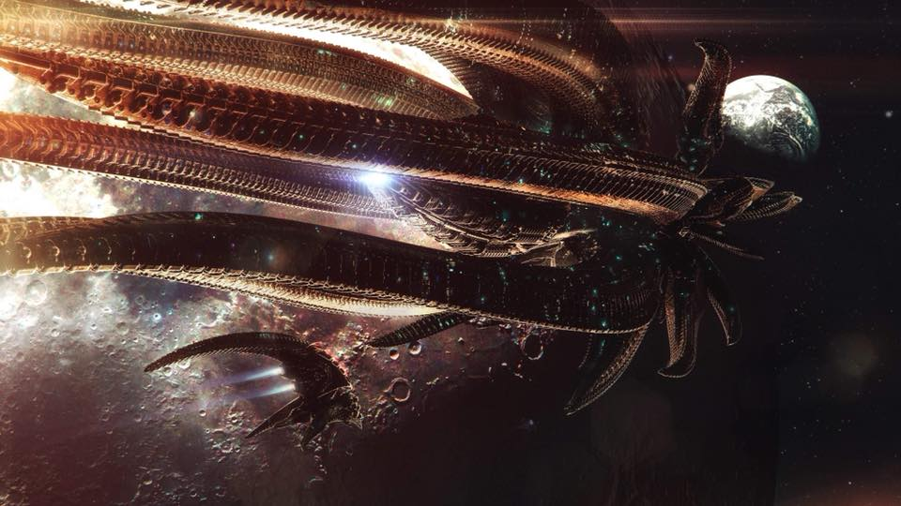

**Version 2, Narrative Event Pack – 28th of September, 2024**

The event will be held on 28th of September, 2024 at Firestorm Games, Sloper Road, Cardiff, CF11 8AB. Players should arrive for set-up at 8.45am. Games and demos start from 09:15.

|  |  |  |
| --- | --- | --- |
| Player Meet and Greet | 08:45 – 09:15 | Introduction and Registration |
| Training Simulations | 09:15 – 10:45 | Free Play and Coaching |
| Break | 10:45 – 11:00 | Comfort Break – Optional |
| Training Simulations | 11:00 - 12:30 | Free Play and Coaching |
| Lunch | 12:30 – 13:15 | Hot Lunch Provided |
| Data Salvage | 13:15 – 15:45 | Narrative Game |
| Break | 15:45 – 16:00 | Comfort Break – Optional |
| Severed Supply Lines | 16:00 - 19:30 | Narrative Game |
| Prize Giving | 19:30 - 20:00 | Awards and Recognition |

**Scene: Command Briefing Room, Naval Academy, UCM Home Fleet Headquarters**

Admiral Garza stood at the head of the room, the light from the holographic projector casting a blue hue across his stern features. The room was filled with fresh cadets, their faces a mix of excitement and apprehension. They had heard whispers about the mysterious new threat, but now it was time for the official briefing.

"Cadets, attention!" Garza barked, and the room snapped to silence. "You are about to embark on a critical phase of your training, one that will determine your readiness to defend humanity against a formidable new enemy. Little is known about these antagonists, but what we do know is deeply troubling."

The holographic display flickered, showing distorted footage of complex, almost skeletal-looking ships ambushing UCM scouting groups and isolated skirmishing fleets in deep space. The ships moved with an eerie, menacing precision.

"They have identified themselves as the Bioficers," Garza continued. "We have limited intelligence on their origin or their motives, but their tactics are clear; they specialize in ambush raids, striking quickly and disappearing before we can mount an effective counter-attack. Our losses have been significant and the frequency of these raids appear to be exponentially increasing."

He paused, letting the gravity of the situation sink in. "But today is not about mourning our losses. Today is about preparing you to fight back. You will start with a suite of training simulations to familiarize yourselves with your ships, crew and the basics of naval engagement. Consider these simulations your last chance to make mistakes without dire consequences."

The cadets moved to the training grounds, a vast area filled with simulators and mock-up control stations. They paired off, nervously eyeing the complex controls and the simulated space battlefield displayed on their screens.

Instructor Darnell, a grizzled veteran with more battles than he cared to count, walked among them, offering gruff advice and sharp corrections. "Remember, cadets, your ships are an extension of yourselves. Learn their strengths and weaknesses, and use them to your advantage. The Bioficers won't give you a second chance."

**Classification Unknown:**

Weapons Free brings you a narrative event intended for players to learn how to play the new Dropfleet Commander rule set and participate in a pair of narrative missions to get a feel for the game. Given the expected arrival of the second edition of the game, the timing of this event is ideal for brand new, returning or experienced players alike. Whereas we do not know the exact date of release at this time, we are aware that version 2 **will** be released before the start date of the event.

**List Building:**

Fleet Lists The maximum points allowed for fleets in this tournament is 999 points (including the points cost of the Admiral). Presently, this will be a ‘Skirmish’ size list, however changes in the rule set may impact the way these are built. Standard fleet composition rules apply. All five/six factions are legal along with all ships available on the official fleet builder. Though you may not include space stations nor famous admirals in your fleet.

**Multiple Lists/Fleets:**

Players are encouraged to try out new fleets, ships and lists over the course of the day. If you have a larger than 999-point collection or other factions, feel free to bring more and chop-and-change your list over the course of the day.

**Fleet Building for Beginners:**

If you are a beginner, new to the game or simply out of practice, all ticket holders can make use of an ‘Advice and Guidance’ service where they can discuss list builds, general tips and tactics or rules clarifications ahead of the event. This will be set up as a Discord channel, but to register your interest, simply email a screengrab of your ticket purchase confirmation to weaponsfreeto@gmail.com and the link to the private Discord will be sent out to you ASAP. We will be using this channel to communicate changes in rules for list building as the new game lands and will have support to convert your list to the new rules if required.

**Unpainted/Proxy Miniatures:**

There will no requirement for painted fleets to participate, however in the event of a ‘Best Painted’ award being offered, unpainted fleets will not qualify. We will allow suitable conversations/proxies as-long-as it is clear what the model is representing and that the majority of your fleet is constructed using official TTCombat models. If you have any queries about this, contact the TO ahead of the event to discuss.

**Prizegiving:**

Prizes will be awarded for Best Painted. Further Prizes will additionally be awarded as Spot Prizes for achieving hidden objectives over the course of the event.

**How to Register:**

1. Entry fee is £25.00 which includes a hot lunch, provided by the Firestorm Games cafeteria. Use the link below to secure your ticket.

https://www.thebattlefields.co.uk/events-at-the-battlefields/weapons-free-4-dropfleet-commander-tournament

1. Build your fleet in TTCombat’s official Dropfleet Commander Fleet Builder

https://dropfleetcommander.com/builder/

1. Once built: click ‘View/Print Fleet’; then click ‘Print Fleet with Ship Stats’. Print your fleet list/lists as a PDF document and email your PDF to the TO before (insert date):

weaponsfreeto@gmail.com

**What Players Need to Bring:**

* At least one assembled 999-point fleet
* Activation cards
* Two copies of your fleet list/s: one to show your opponents and one to give to the TO
* Access to the Rulebook and FAQs/Errata
* Dice and tape measure
* Ground asset tokens, launch asset tokens and crippling damage tokens

**Photography and List-Sharing Consent:**

Over the course of the event, the TO/s will be moving around and taking photos for promotional use including posts on social media platforms. There will also be opportunities for players to display their fleets for photography during the breaks in play. It is assumed that all ticket holders consent to the sharing of their fleet and lists for the agreed purposes above. If you would like to opt out of this consent to sharing, please email the TO before the day of the event weaponsfreeto@gmail.com.

**No Fleet, No Problem…(maybe):**

We have many regular players with multiple fleets; some of which have shared an interest in loaning a fleet out to try if needed on the day. This is subject to availability and player discretion. Email the TO if you require this option BEFORE purchasing your ticket.

**After Each Game:**

After the game both players should clear the play areas and be prepared to have to switch tables ahead of the next game round. Take care to collect all our tokens and dice before moving tables and ensure you don’t leave any food waste, drinks or rubbish behind.

**Disputes:**

If a rules dispute arises, players should try to resolve the issue themselves. However, if they feel an amicable decision cannot be reached then they should call over the TO. It is strongly advised that all players be aware that from the moment of entry into the event the decisions of the TO regarding the fair adjudication of the event rules and all issues of health and safety are final. No discussions should be entered into once a decision has been made.

**Scenarios:**

All games prior to the lunch break will be casual, guided and support games to allow players to learn the basics of the game and the new rules. Following lunch, players will be able to participate in a pair of narrative scenarios with a chance to win prizes for carrying out specific challenges and actions.

All scenarios have been designed specifically to meet the event narrative and will be emailed to players directly along with the event narrative closer to the date. To get your copy of the scenarios, please email weaponsfreeto@gmail.com and send a copy of your ticket purchase.

**Be sure to dust off those kickstarters and starter sets and plot your sub-light jump to Weapons Free, Classification Unknown - Cardiff!**

**See you all in the training suite.**