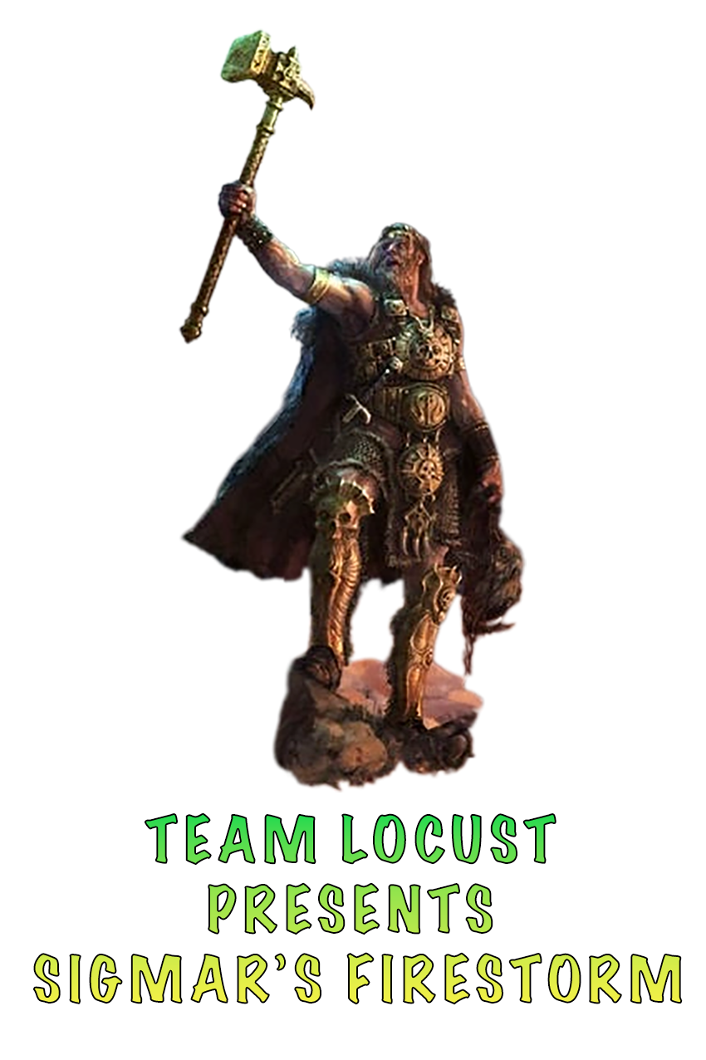

EVENT ESSENTIALS

System: Warhammer Age of Sigmar Pitched Battles
Location: Firestorm Games (Cardiff),Sloper Road, Cardiff, CF11 8AB, United Kingdom

Battle Size: 2000 points

Board Size: 60” x 44”

Missions: Pitched Battle Battleplans from the Generals Handbook

No. of Games: Three

Event schedule

Registration 9-9:30
Game 1 -9:30
Lunch -12:00 Included in ticket price
Game 2 -1:00
Game 3 -4:00
Awards -7:00

Prizes

- (Player vote) Best Individual character (painting, kitbashing etc.)
- (Player vote) Best Army (painting, theme, kitbashing, etc.)
- 1st Place
- 2nd Place
- Wooden Spoon

TOURNAMENT RULES
● The Best Coast Pairings App will be used for the tournament. Each player must have the app available.
● Age of Sigmar 4.0 rules will be in use.
● 2000-point list using the rules and restrictions provided in the Pitched Battle section from the General’s Handbook 2024-25
● Any kind of ability you can choose before the game must be chosen before the event and recorded on your army roster clearly. These choices are made for the entire tournament and cannot be changed during the event.
● There are basic painting requirements, and all models must be appropriate based on the correct size base.
● Each Player must adhere to the Player's Code.
● Lists must be entered into BCP by 15^{h} November and must list all points/terrain/ /enhancements.
● New publications (battletomes, GHBs), erratas, faqs and battlescrolls must have been released a week in advance of the list deadline.
● Your dice must be standard cubes.

THE PLAYER'S CODE
● Always be polite and respectful.
● Always tell the truth and never cheat.
● Arrive on time with all of the things you need to play the game.
● Make a respectful gesture to your opponent before and after the game, such as offering a handshake or fist bump.
● Avoid using language your opponent might find offensive.
● Offer your opponent a chance to examine your army roster before the battle starts.
● Answer any questions your opponent has about your army and the rules that apply to your army.
● Measure moves and distances carefully and accurately.
● Give your opponent the chance to examine your dice rolls before picking up the dice.
● Remind your opponent about rules they may have forgotten to use or that they have used incorrectly, especially when doing so is to your opponent’s advantage rather than your own.
● Never deliberately waste time during a game.
● Avoid distracting an opponent when they are trying to concentrate and be careful to respect their personal space.
● Never complain about your bad luck or your opponent’s good luck.
● Never collude with an opponent to fix the outcome of a game.

ROUND SCORING
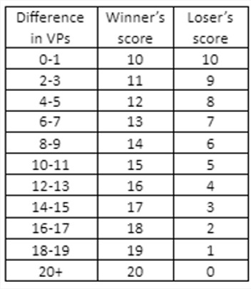
Games will be scored using a VP Differential Point system. You score battle points (BP’s) for every game based on the difference between both players’s scores. You will be required to record your exact victory point scores down for each round, as these will be used to split the final rankings at the end of the tournament. This means that you should always have something to play for in every game, even if you are heading for a loss, as you will want to maximize your ranking for your win/loss bracket.

There is a chance that you’ll be able to get a draw if your VP differential is very very close (within the bracket of 1pt). A draw is better than a loss and remember you’ll still gain overall points for a draw. (Table taken from Southhampton GT pack by UKTC)

Scores will be submitted using the BCP (Best Coast Pairings) player apps, but the TO can submit scores if needed/requested.

TERRAIN
Table Layouts
Terrain will be provided by Firestorm Games and will be set out on tables prior to Game 1. Before each game please adjust the terrain to follow the rules for objective and terrain placement. If you have any issues with terrain placement please ask the staff for help. If the terrain is based, then that base is used to define if a model is Wholly On Terrain.
Faction Terrain
Every effort should be made to allow players to use their faction terrain that they have spent time to paint. If faction terrain cannot be placed then please speak to a tournament organiser who will adjust the battlefield to accommodate the piece. This only applies to Faction Terrain that is set up before the game begins.

HOBBY & PAINTING
This section is to detail what we allow at our events. We understand painting a full army can be a difficult process and a big time investment but we will not allow unpainted or solely primed models. Some events will discuss a 3 colour minimum but we interpret that as having models “Battle Ready” which means the main colours + a wash (if your scheme uses a wash) and to be based. This is encouraged but we love to see progress so if the army isn’t fully painted that is fine!

We will allow 3D-printed models, kitbashes and proxies however these need to be within the following constraints:
● The model that you are using has to have the same base size and size profile as the model it represents.
● Has to clearly represent the unit.

Anything that goes against these constraints will be flagged and you will be asked to remove them from the game and count it as destroyed. Consistent use of these models after the verbal warning will result in escalation and potential removal from the event without a refund.

If you are unsure if your models fit within the constraints, then feel free to email us with pictures, and we can review it from there.

Separately for those inclined. There will be hobby-related prizes for:

● (Player vote) Best Individual character (painting, kitbashing etc.)
● (Player vote) Best Army (painting, theme, kitbashing, etc.)

PAIRINGS
Pairings will be random in the first round. The second and third rounds will be swiss pairings.

ROUND TIMING
Each round is 2:30 hours.

A call will be put out with 20 minutes remaining not to start any more additional rounds, if they game has not been completed they will need to proceed to Discussion of game results below. once time has been called on the round you will have 5 mins to get a result in or result in a draw.

Discussion of game result

If a game has not reached a conclusion by the end of the round or if one player is tabled, the players must come to an agreement (math-hammer) on who would win and which auxiliary objectives would be scored if the game had concluded 5 full battle rounds. If an agreement can not be made, a TO should be informed, and the TO’s decision will be final.

Quit Policy
We expect all players to see the game through to the very end and not concede, as doing so can impact tiebreakers and, ultimately, the final rankings. In the unlikely event that a player does concede before the game has reached its natural conclusion, then the conceding player earns a loss and zero points. The winning player records a major victory and maximum points for their grand strategy and battle tactics for the remaining rounds. Of course, if you have some kind of emergency that means you can’t proceed, just let us know as soon as you can.

LATE ARRIVALS
● If more than one player arrives late for the first round, the late arrivals will be paired against each other.
● If there is an odd late arrival in the first round, they will receive zero points.
● If a player arrives more than 15 minutes late for a round other than the first, they score zero for that round (and the opponent scores 20). Circumstance will be taking into account.

