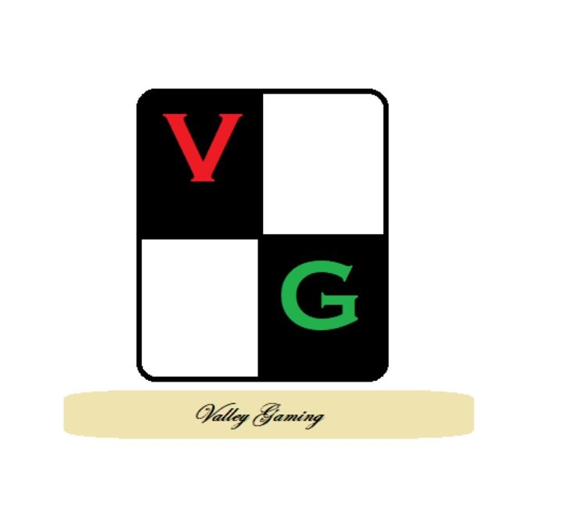
Operation Valley Gaming 2025

Flames of war Late War
100 Points Event

21/22 June 25

Dates: Saturday and Sunday, June 21/22. 2025

Venue: Firestorm Games Cardiff, Sloper Rd, Cardiff, CF11 8AB

Tournament Format: V4 Flames of war late war, 100 points. 5 rounds over 2 days, 2.5 hours per round, extended battle plans, 2 formation limit. Players can only have one allied nation or support unit from another nations. Late war leviathans are not permitted.

Points: 100 points

Tournament sign-up: Tickets on sale at firestorm games

List Submission: emal robjones555607@yahoo.co.uk
- All lists must be produced on forces of war and include the players name and be submitted as a PDF.
- Players may submit a Axis and an Allied list. Players should note ‘Primary’ or Secondary’ in the list title which will considered their preference for match ups.

Books: Players may use any V4 LW book published before Mar 25 (excluding any ‘Late war leviathans’). No community or user produced cards may be utilised.

List submission Deadline: 06 June 2025.

Tournament Schedule
Sat 21 June 25
9:00 – 9:30 Check-in Briefing
9:30 – 12:00 Round 1
12:00 - 12:30 Lunch
12:30 – Round 2
15:15 – 17:45 Round 3

Sunday 22 June 2025
9:30 – 12:00 Round 4
12:00 – 12:30 Lunch
12:30 – 15:00 Round 5

15:00 – 15:45 Table clear up and results

If all games finish early and the next draw is ready then all time will be brought forward to allow people to finish the day early.

Rules and Regulations
- All armies must be fully painted. No proxy models are allowed, as the player should use the correctly sized vehicles as well as gun and infantry teams. Infantry teams may represent different weapon configurations e.g. a rifle/mg armed infantry platoon may be used as mg armed infantry platoon as long as platoons are clearly marked. If in doubt ask prior to the event.
- Units should be clearly distinguishable i.e. be able to differentiate one infantry/tank platoon from another.
- The event will randomise match ups for round 1 with subsequent rounds based on score. Players will not play the same player more than once.
- In instances where only 1 player at a table has 2 lists, they should select the list required to generate a blue/red match up. Where both players have 2 lists players should compare both their lists and see if a primary and secondary list match would produce a red vs blue game. If not, both players should roll a dice and the highest scoring player will use their primary list with their opponent the secondary.
- Extended battle plans will be used with a single dice rolled by the TO for each round. The score of the dice will be used for all games. Remember to download or print the most recent mission pack prior to the event.
- Game time: Players are responsible for monitoring the time and the TO will announce time intervals throughout the tournament. A true act of sportsmanship is not starting a new turn if both players will not be able to finish that turn. The game should be called if both players cannot finish their turns and the results should be calculated.

Table: You are more than welcome to supply your own table for the event. If you can supply a table please email robjones555607@yahoo.co.uk

Terrain: Players are advised discus terrain before they start the game and agree definitions (low rise vs hill). They should also mutually agree how to position models for ‘hull down’. For simplicity and speed, all tall terrain is to be considered ‘infinitely tall’. i.e. you can see over smaller building if you are in a taller one.
Measuring: All movements of models should be done with a tape measure/measuring stick. Once lifted a model may not be returned to its starting position unless a marker was placed down to confirm its starting position.

Dice: Each player is to supply their own dice. A player may request to use their opponents dice at any point. To avoid confusion over ‘cocked dice’ it is suggested any dice not flat on the table (or in a dice tray) are re-rolled. Dice trays must be on the table and rolls visible to your opponent.

Slow Play: Slow play is to be actively discouraged, repeated offenses may result in loss of points or forfeited matches. Slow deployment is also considered slow play.
If a player feels their opponent is deliberately being slow in deployment or during the game, contact a TO and they will observe and set time limits if required. The TO may award extra time if slow play has been observed.
Ending a game: When time is called the game must immediately finish the current round (i.e. even out turns for both players). New turns cannot be started even if starting a new turn would award an immediate victory or cause a player to make a company morale check.
Cheating: If a TO observes or has an issue of cheating raised (and upheld) to them then the offender will forfeit their current game and score 0 points. Their opponent will score 8 points. If the player is observed cheating again then they will be asked to leave the event (no refund offered). The TO’s decision is final.
Rules queries: sometimes there will be differing interpretations of the rules. Either they are unclear, or someone has mis-understood. Players should have access to the latest LFTF and check if the answer is in it. If not and both players agree then roll a dice to decide the outcome. Otherwise ask a TO to adjudicate; their decision is final.
Painting Competition: Any players that wish their armies to be considered for the best painted competition will stage them on their current table at lunch on the Sunday. Only armies consisting entirely of BF models (excluding bases abn obj markers) will be considered for the painting competition. The display board will not be judged.

Army lists must be submitted to robjones555607@yahoo.co.uk using forces of war and in PDF format.
Tournament Scoring:
Victory points will be used to determine the final placing at the event. In the case of a tie the number of units lost will be the tie break, followed by number of best sport votes as a second tie break and then number of 8:1 wins as the third tie break.

Awards:
- 1st Place
- 2nd Place
- 3rd Place
- Best Sportsperson
- Best painted
- Wooden spoon (last place)
Best sport is chosen by the players. At the end of the tournament players will choose the best sportsperson they played. The player with the highest score will win the award. If tied, then the breaker will be VPs across all 5 games.
Best painted will be chosen by the event organiser.

